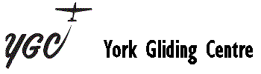

2024 Course Booking Form

Course Start Date
Name
Address

Telephone Home
Mobile
Work
Email
Previous Experience
Please send the completed form to Graeme Alexander (email address below) and your non-refundable deposit of £50.00 to the office, along with your course/temporary membership fee of £50.00 if you are not already a member. (Your membership will start on the first day of the course unless you request it to start earlier) This will then confirm your booking.

York Gliding Centre Ltd.
Rufforth
York
YO23 3NA
01904 738694
gcalexander@mail.com

